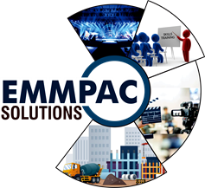



**EMMPAC SOLUTIONS**

*Complete Glee Under One Roof*

* **Constructions and Consultancy.**
* **Awareness Activities, Training & Capacity Building.**
* **Consultancy & Third-Party Inspection.**
* **Health checkup of Structure, Pile Testing, Stability test.**
* **Specialized Constructions Solutions.**
* **Waterproofing, Repair & Retrofit, Grouting’s, Coatings.**
* **Thunder & Lightening arrest of buildings.**
* **General Order Supplier.**
* **Documentary, Short Films, Feature Films Productions.**
* **Advertisements and Shows.**
* **Event Management.**
* **Waste Management.**

Regd. Add :-Emmpac Building, Ranchi Road, Opp. Sainik School, Behind Gorain Hotel, Purulia – 723149 Purulia Town office :- Sansar Plaza, near Bhagat Singh More, J K College Road, Purulia- 723101 Corp. Ofc :- Sumami Enterprise, Thakdari Road, CG Block, Action Area-1,New Town, Kolkata, 700156 Br. Office :- # 3C, Lakshmi Savitri Appartment, Tiwari Tank Road, Hindpiri, Ranchi, Jharkhand. Mobile :- 8877000030 , 8116915768 , 9073374695 , 9771417252 E-mail : emmpacsolutions@gmail.com www.emmpacsolutions.com

GST Number :- 19AALFE245H1Z6 TAN Number :- CALE08382D

**COMPANY BRIEF PROFILE!**

**EMMPAC SOLUTIONS** is formed by a group of Entrepreneurs and Professionals having versatile knowledge and experiences in Multi-Sector. Our aim is to provide the right solutions and delight to our client. Our motto is ***COMPLETE GLEE UNDER ONE ROOF***.

We value our Clients for their trust upon us. This is because of our precise works and Prompt services.

EMMPAC SOLUTIONS has a team of Creative People, Writers, Authors, Entrepreneurs, Social Workers, Specialized Engineers and Consultants. With the legacy of decades, the valuable members have rich versatile experiences of close interactions and dealing with people from grass root levels up to the top-notch levels. We discuss, understand, inspects, analyse the requirements of the clients and provide customised solutions. We are team with leadership qualities having innovative business knowledge asserting risk tolerance and dealing with assertiveness.

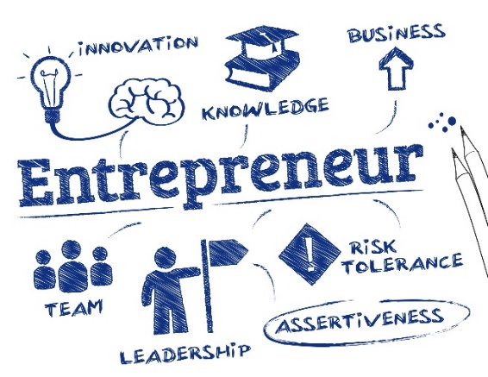 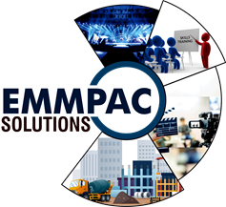

**Our Services**

* **IEC, Awareness Activities, Training & Capacity Building.**

We have expert IEC team for conducting customised TRAINING & WORKSHOP, SKILL DEVELOPMENT, AWARNESS ACTIVITIES, CAPACITY BUILDING at all levels. We provide customise training and workshop programmes for specific group about and with latest technology and practices. We have worked as an outsourced company for election commission (SWEEP) in Jharkhand for generating awareness among voters resulting increase in voters’ turnout. We provide trainings and workshop about the latest construction practices to Engineers, Architects, Contractors, Masons and IHB. Our team has worked for JAL JEEVAN MISSION programme. We have generated awareness through the local folk dances and folk songs with the programme specific agenda. Our training and workshop have a positive impact and increases the efficiency of the participants. We have done program with ICCW (International Center for Clean Water) an initiative from IIT MADRAS in West Bengal. In Jharkhand and West Bengal, we are continuously doing awareness activities to upgrade the living standard of under privilege people. We provide services and awareness for the all types of waste management and conservation of environment. We have collaboration with a NGO by the name DHARTI AABA FOUNDATION to work for social cause.

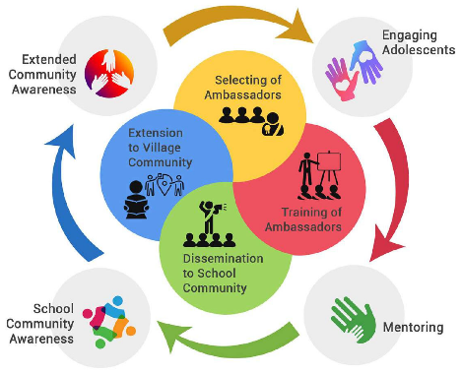 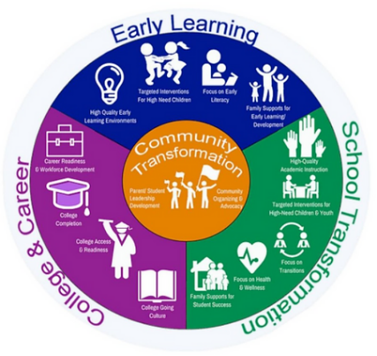 

* **Constructions & Consultancy.**

In the field of Construction works we have expert specialized team of Engineers to give right solutions from DPR to Completion. We inspect evaluate and give the customised solutions with the right products. We have experience in latest Construction practices and technology. We find out the reasons for any issues or problems, find out gaps, the pain points, the reasons for the different types of construction failures and give the right solutions. We just don’t take clients project but we own it. We provide value addition works. We have collaboration with European companies for the value-added products and technologies. As a specialized civil engineers, we have advantage of making and implementing Specifications, BOQ, Tendering, Executions and handover within stipulated time frame with 100% client satisfaction. We adopt latest construction practices with innovative products and its proper applications.

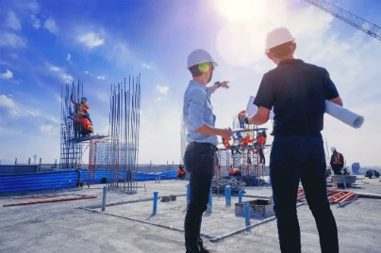 

* **Health checkup of Structure & Specialized Works.**

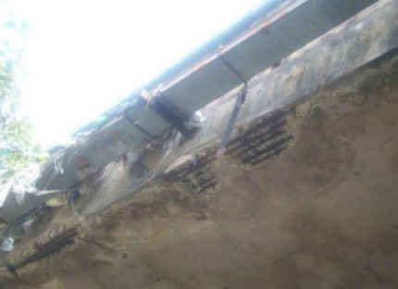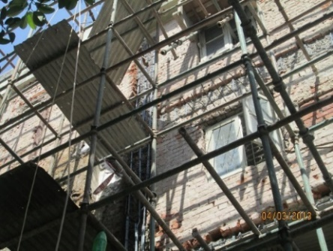 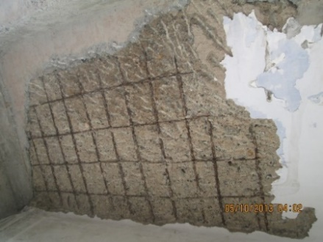

* **Waterproofings & Repair and Retrofittings**

We have experience and specialized Civil Engineer to do value addition works of doing health checkup of old and new structures. We have collaboration with German Companies in doing the Specialized Civil Engineering works. We inspect, analyses and provide the right solutions for the issues. We under take the specialized works of different types of WATERPROOFING, REPAIR & RETROFITING, Restoration of Structures, Strengthening, Seamless Floorings, GROUTING, Strengthening, Guniting, Micro-Concreting, Pre-Mixed Plaster, Coatings, Anti-Corrosive works, Insulation of buildings, Sound Proofing, Green Rated Buildings, Stability Checkup, Pile Testing’s. We work to provide right solutions with value addition. We do restoration works of heritage buildings and structures.

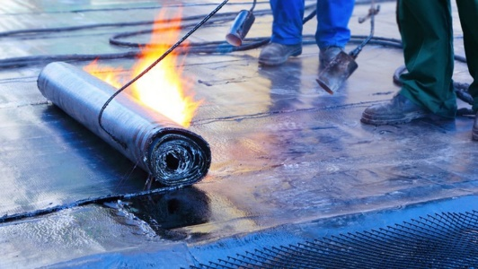 

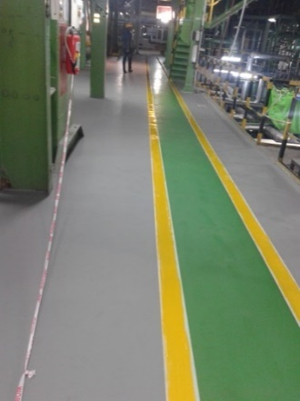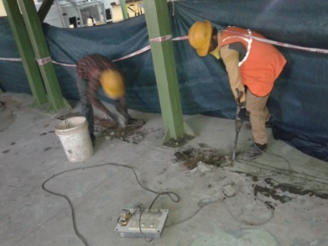 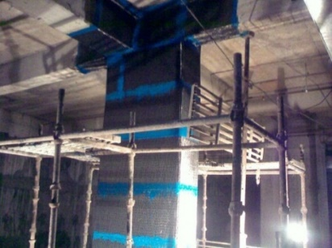



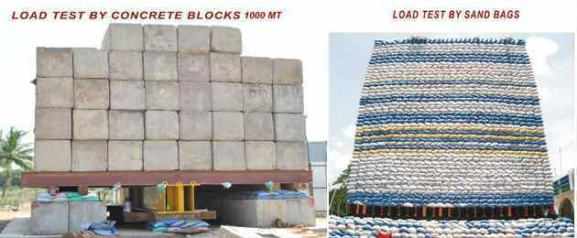

* **Thunder & Lightening Protection of buildings.**

*Lightning has been* ***biggest killer and mysterious disaster.*** Lightning strikes has increased 34% compared to year on year in India. The **frequency and intensity**of lightning strikes in India are expected to **increase**by **10 to 25 percent** and **15 to 50 percent** respectively the end of this century. The Death due to lightening once taken Cumulative account for around **33% of total death** due to natural disaster in India. In two tier and three tier districts of India this is a major issue. We provide customised lightening Protection System for all types of buildings ensuring safety to buildings, assets and life.

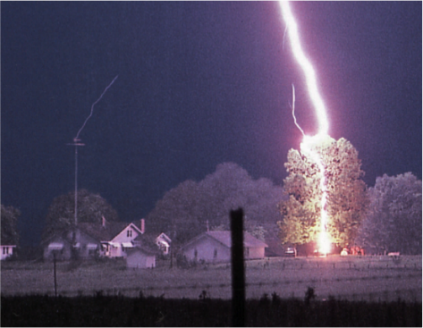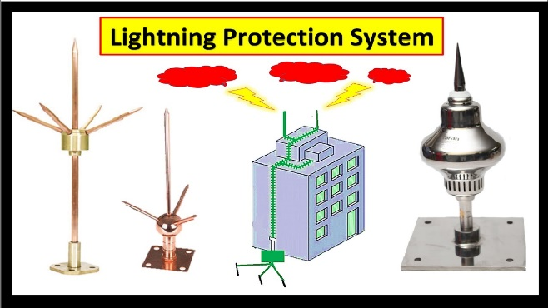

* **Documentary, Short Films, Advertisements & Feature films Productions.**

We make Documentary Films, Short Films, Music Albums, Feature Films and advertisements. We have made two regional feature films MOHAI JUNGLE and GANGWA in Nagpuri Language and one in Hindi LOVE STREET. We have made one documentary film on Birhore. We have shooted for tourism department of Jharkhand for water sports activities. We have made unlimited hit musical albums. We have dedicated and experience team for all types of creative works. We have successfully done filming with world famous film maker from Israel Mr. Dan Wolman. We have represented ISRAELI Cinemas as a delegate in 2019 in GOA International film festival. We have Bengali film jungle mahal.

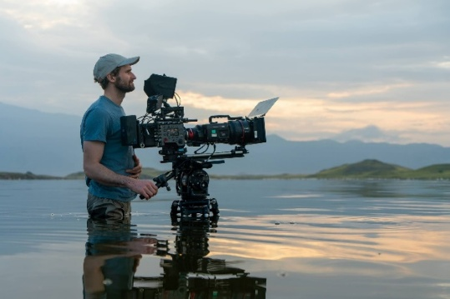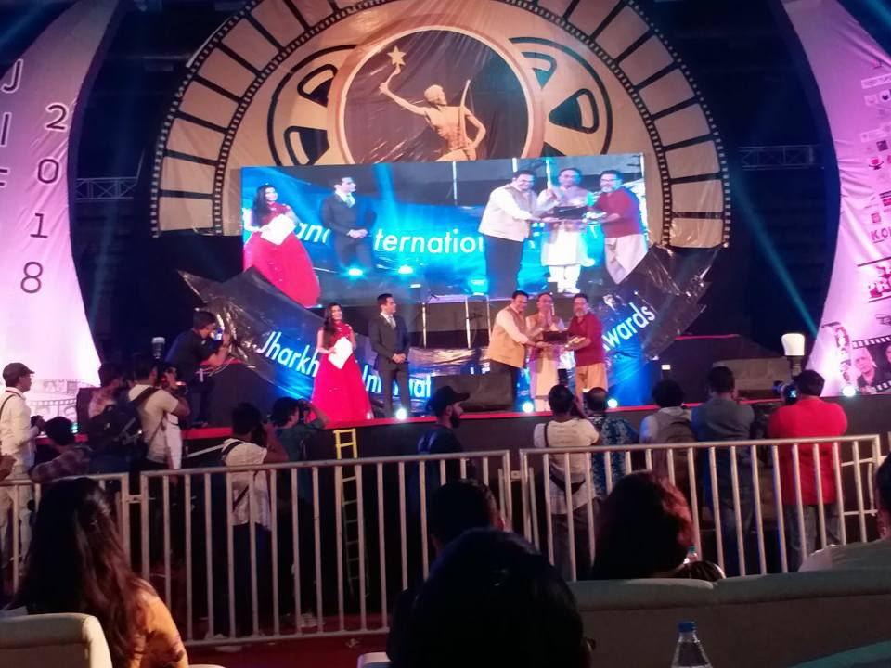

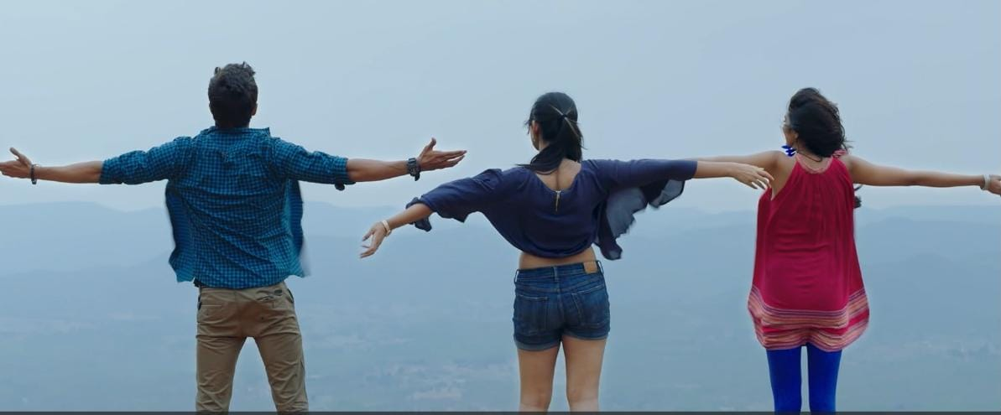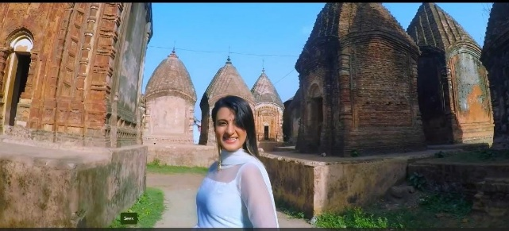

* **Event Management.**

We do EVENT MANAGEMENT for Promotional Events, Launching Ceremonies, Election Events, Opening Ceremonies, Musical Programmes, Live Concerts, Book fair, Film Festivals, Pageant Competition, Stage shows etc. Our team members have conducted INTERNATIONAL FILM FESTIVAL successfully. We make our clients feel glad by our works.

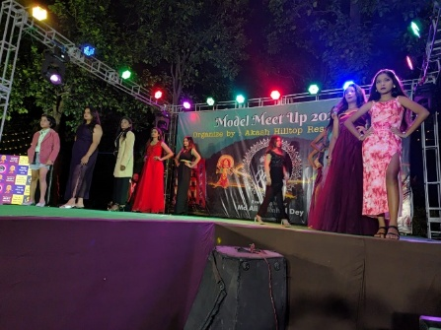 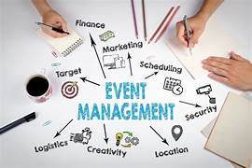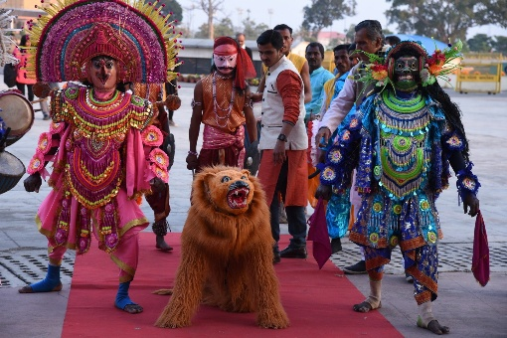

* **Waste Management**

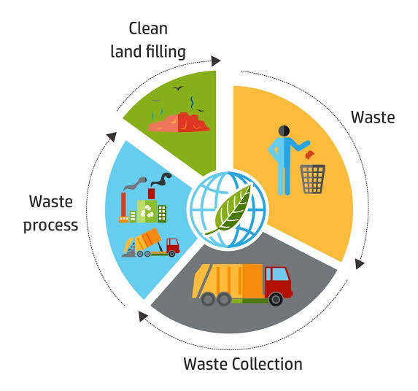 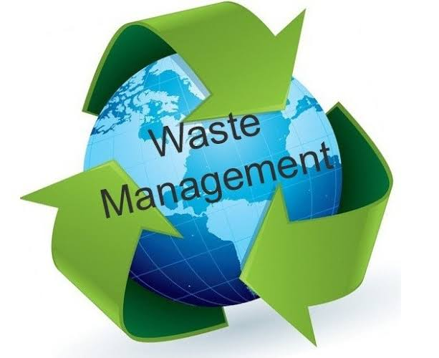

Emmpac Solutions encompasses the complete cycle of managing all types of waste from its generation to its final disposal, with the goal of minimizing environmental and health impacts through landfill, incineration, recycling and composting.

Our motto “COMPLETE GLEE UNDER ONE ROOF”

